**Edwest Examination, 2016**

**Governor Stirling Senior High School**

**Semester 1 Exam 2016**

**Question/Answer Booklet**

HUMAN

BIOLOGICAL

SCIENCE

**Unit 1**

Name ________________________

Class ________________________

Teacher Name ________________________

#### Time allowed for this paper

Reading time before commencing work: ten (10) minutes

Working time for paper: two and a half (2.5) hours

**Materials required/recommended for this paper**

To be provided by the supervisor

**This Question/Answer Booklet**

**Multiple-choice Answer Sheet**

To be provided by the candidate

**Standard items: pens, pencils, eraser, correction fluid, ruler, highlighters**

Special items: non-programmable calculators satisfying the conditions set by the Schools Curriculum and Standards Authority for this course

**Important note to candidates**

No other items may be taken into the examination room. It is **your** responsibility to ensure that you do not have any unauthorised notes or other items of a non‑personal nature in the examination room. If you have any unauthorised material with you, hand it to the supervisor **before** reading any further.

**Structure of this paper**

|  |  |  |  |  |  |  |
| --- | --- | --- | --- | --- | --- | --- |
| **Section** | **Number of questions available** | **Number of questions to be answered** | **Suggested working time**  **(minutes)** | **Marks available** | **Percentage of exam** | **Student Score** |
| **Section One:**  **Multiple-choice** | 30 | 30 | 40 | 30 | 22 |  |
| **Section Two:**  **Short answer** | 9 | 9 | 80 | 90 | 64 |  |
| **Section Three:**  **Extended answer** | 2 | 1 | 30 | 20 | 14 |  |
|  | | | | | 100 | ____/140 |

**Instructions to candidates**

1. The rules for the conduct of Western Australian external examinations are detailed in the *Information Handbook 2016.* Sitting this examination implies that you agree to abide by these rules.

2. Answer the questions according to the following instructions.

**Section One**: Answer all questions on the separate Multiple-choice Answer Sheet provided. For each question shade the box to indicate your answer. Use only a blue or black pen to shade the boxes. If you make a mistake, place a cross through that square, do not erase or use correction fluid, and shade your new answer. Marks will not be deducted for incorrect answers. No marks will be given if more than one answer is completed for any question.

**Sections Two and Three**: Write answers in this Question/Answer Booklet.

3. You must be careful to confine your responses to the specific questions asked and to follow any instructions that are specific to a particular question.

4. Spare pages are included at the end of this booklet. They can be used for planning your responses and/or as additional space if required to continue an answer.

* + Planning: If you use the spare pages for planning, indicate this clearly at the top of the page.
  + Continuing an answer: If you need to use the space to continue an answer, indicate in the original answer space where the answer is continued i.e. give the page number. Fill in the number of the question(s) that you are continuing to answer at the top of the page.

**Section One: Multiple-choice 22% (30 Marks)**

This section has **30** questions. Answer **all** questions on the separate Multiple-choice Answer Sheet provided.

For each question shade the box to indicate your answer. Use only a blue or black pen to shade the boxes. If you make a mistake, place a cross through that square, do not erase or use correction fluid, and shade your new answer. Marks will not be deducted for incorrect answers. No marks will be given if more than one answer is completed for any question.

Suggested working time for this section is 40 minutes.

1. In the diagram below, the process described is

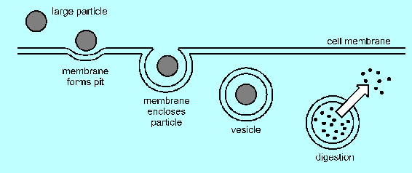

1. osmosis.
2. pinocytosis.
3. phagocytosis.
4. exocytosis.

*Question 2 refers to the diagram below.*

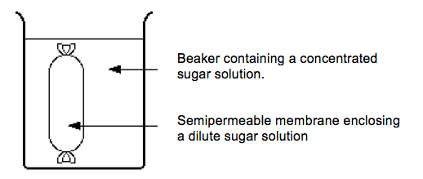

1. When osmosis occurs in the above experiment, some of the
2. sugar molecules will move from the concentrated to the dilute solution.
3. water molecules will move from the concentrated to the dilute solution.
4. sugar molecules will move from the dilute to the concentrated solution.
5. water molecules will move from the dilute to the concentrated solution.
6. The type of tissue lining the alimentary canal is
7. epithelial tissue.
8. connective tissue.
9. muscular tissue.
10. contractile tissue.
11. Which of the following best describes the structure of the cell membrane?
12. non-permeable protein bilayer studded with phospholipids
13. semi-permeable phospholipid bilayer studded with proteins
14. semi-permeable protein bilayer studded with phospholipids
15. non-permeable phospholipid bilayer studded with proteins
16. Which of the following methods of movement across the membrane do not require energy?
17. osmosis, diffusion & facilitated diffusion
18. osmosis, diffusion & active transport
19. active transport, vesicular transport & facilitated diffusion
20. active transport, facilitated diffusion & osmosis
21. A balanced diet is an important factor in the growth of children. The table below provides information about a breakfast cereal.

|  |  |
| --- | --- |
| ***Ingredients*** | ***Mass per serving*** |
| Protein | 6g |
| Carbohydrate | 62g |
| Fat | 4g |
| Vitamins | 1.4mg |
| Iron | 2.4mg |

One serving of breakfast cereal will provide 20% of a child’s daily requirement of iron. How many mg of iron are required daily by a child?

1. 0.12
2. 0.48
3. 12
4. 48
5. A red blood cell will lose water when placed in a 20% salt solution. This happens because the red blood cell
6. has the same water concentration as the salt solution.
7. is hypertonic to the salt solution.
8. is isotonic with the salt solution.
9. is hypotonic to the salt solution.
10. Which of the following is an example of an anabolic reaction?
11. digestion of starch by enzymes
12. formation of protein by amino acids
13. oxidation of glucose during respiration
14. breakdown of hydrogen peroxide by catalase
15. Enzymes are biological catalysts. Enzyme molecules are made of
16. fat.
17. protein.
18. vitamins.
19. carbohydrate.
20. The active site of an enzyme is complementary to
21. one type of product molecule.
22. all types of product molecule.
23. one type of substrate molecule.
24. all types of substrate molecule.
25. After running a marathon, an athlete experienced muscle fatigue. Which of the following had increased in his muscles?
26. glucose
27. carbon dioxide
28. ATP
29. lactic acid
30. The flow of lymph in lymphatic vessels is brought about mainly by
31. pumping action of lymph nodes in the neck and groin.
32. osmotic pressure of fluid absorbed by body tissue.
33. pressure exerted by surrounding muscles on contraction.
34. two lymphatic ducts opening into veins from the arms.
35. Energy produced by cellular respiration is stored as
36. deoxyribonucleic acid.
37. adenosine diphosphate.
38. ribonucleic acid.
39. adenosine triphosphate.
40. Which of the following lists all elements present in every protein molecule?
41. carbon, hydrogen, nitrogen
42. carbon, hydrogen, nitrogen and oxygen
43. carbon, hydrogen, oxygen and sulphur
44. carbon, hydrogen and oxygen
45. Solid food is passed along the alimentary canal by
46. filtration.
47. digestion.
48. peristalsis.
49. excretion.
50. Yellow bone marrow is found in the
51. epiphysis of long bones.
52. diaphysis of long bones.
53. synovial cavity.
54. articular cartilage.

*Question 17 refers to the diagram below.*

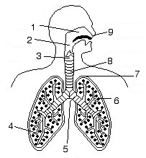

1. Which number identifies the site of gas exchange?
2. 4
3. 5
4. 6
5. 7

18) In the diagram below, structure D

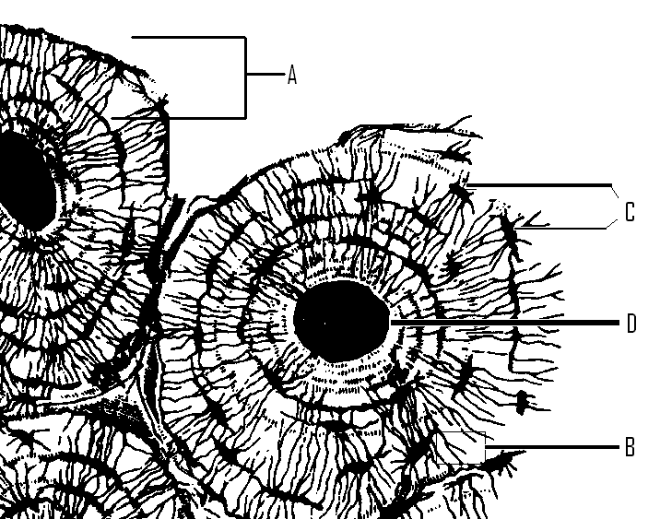

1. stores sodium and calcium.
2. contains yellow bone marrow.
3. contains blood vessels and nerves.
4. removes waste.

*Question 19 refers to the x-ray image below.*

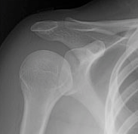

1. The joint shown in the x-ray is an example of a
2. gliding joint.
3. ball and socket joint.
4. hinge joint.
5. pivot joint.
6. The table below shows water gained and lost by the body over a 24 hour period.

|  |  |  |  |
| --- | --- | --- | --- |
| ***Method of water gain*** | ***Volume of water gained (cm3)*** | ***Method of water loss*** | ***Volume of water lost (cm3)*** |
| Food | 800 | Exhaled breath |  |
| Drink | 1000 | Sweating | 500 |
| Metabolic water | 350 | Urine & faeces | 1350 |

What volume of water is lost in exhaled breath?

1. 100cm3
2. 200cm3
3. 300cm3
4. 500cm3
5. The liver carries out over 500 processes and plays a major role in converting toxic substances into less toxic substances. Which line correctly identifies some of the substances produced during deamination by the liver?
6. amino acids 🡪 ammonia 🡪 urine
7. ammonia 🡪 amino acids 🡪 urea
8. amino acids 🡪 ammonia 🡪 urea
9. ammonia 🡪 urea 🡪 amino acids
10. Which of the following substances are normally excreted in urine?
11. protein and urea
12. urea and salts
13. glucose and salts
14. protein and salts
15. A class of students carried out an experiment investigating the effect of exercise on heart rate. Each student carried out the following activities- sitting, walking, jogging, sprinting. Each activity was carried out for 60 seconds. At the end of each activity the heart rate was recorded.

Which of the following would be the dependent variable?

1. type of activity
2. time taken to complete activity
3. heart rate
4. stopwatch used

*Use the diagram below to answer question 24.*

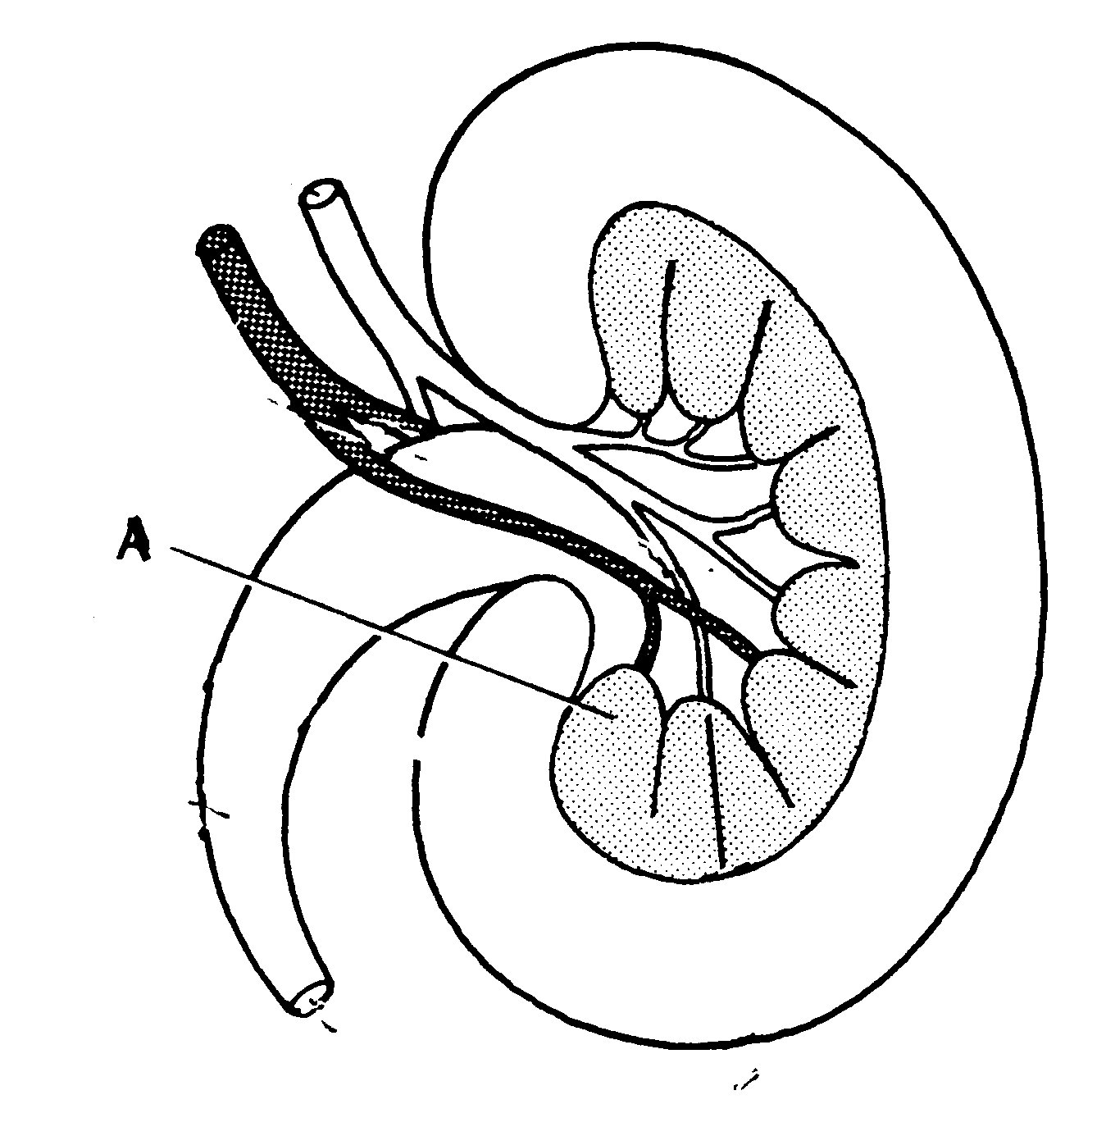

1. On the diagram above, the section labelled A is the
2. medulla.
3. cortex.
4. calyx.
5. pelvis.
6. The table below shows some of the features of blood vessels. Which line correctly describes features of arteries?

|  |  |  |  |
| --- | --- | --- | --- |
|  | ***Direction of blood flow*** | ***Detection of pulse*** | ***Presence of valves*** |
| a | Towards the heart | Yes | No |
| b | Away from the heart | No | Yes |
| c | Towards the heart | No | Yes |
| d | Away from the heart | Yes | No |

*Questions 26 and 27 refer to the diagram below.*

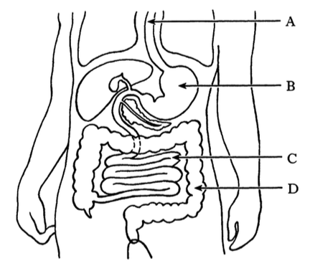

1. In which part of the digestive system is water mainly absorbed?
2. A
3. B
4. C
5. D
6. Which label in the diagram correctly identifies where most nutrients are absorbed into the blood?
7. A
8. B
9. C
10. D
11. Haemoglobin combines with oxygen to form oxyhaemoglobin. Which of the following statements on oxyhaemoglobin is correct?
12. at low oxygen concentrations, oxyhaemoglobin releases oxygen in the lungs
13. at high oxygen concentrations, oxyhaemoglobin releases oxygen in the tissues
14. at low oxygen concentrations, oxyhaemoglobin releases oxygen in the tissues
15. at high oxygen concentrations, oxyhaemoglobin releases oxygen in the lungs

*Question 29 refers to the diagram below.*

1. The function of the chamber marked X on the diagram is to

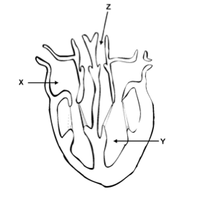

1. pump blood to the left ventricle.
2. pump blood to the body.
3. collect blood from the body.
4. collect blood from the lungs.
5.  Structure A is identifying
6. myosin.
7. sarcomere. A
8. Z line.
9. actin.

**End of Section One**

**Section Two: Short answer 64% (90 Marks)**

This section has **nine (9)** questions. Answer **all** questions. Write your answers in the space provided.

Spare pages are included at the end of this booklet. They can be used for planning your responses and/or as additional space if required to continue an answer.

* + Planning: If you use the spare pages for planning, indicate this clearly at the top of the page.
  + Continuing an answer: If you need to use the space to continue an answer, indicate in the original answer space where the answer is continued, i.e. give the page number. Fill in the number of the question(s) that you are continuing to answer at the top of the page.

Suggested working time for this section is 80 minutes.

**Question 31 (13 marks)**

The diagram below outlines the basic animal cell structure.

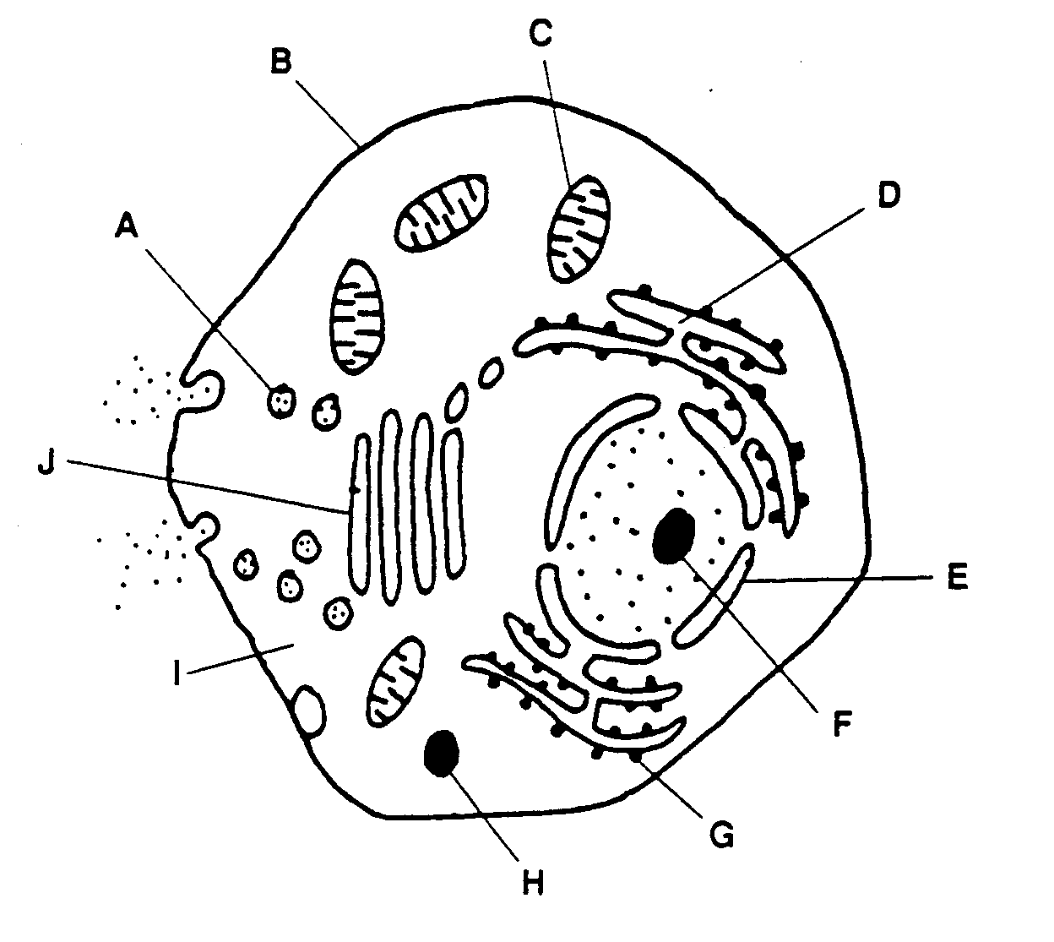

1. Use the diagram to complete the table below. (4 marks)

|  |  |  |
| --- | --- | --- |
| **Letter** | **Name of Organelle** | **Function of Organelle** |
| D |  |  |
|  | Ribosome |  |
|  |  | Packages and processes proteins |
|  |  | Contains digestive enzymes |

The cell membrane controls which substances enter and exit the cell. The diagram below illustrates the movement of two different types of molecule into a cell.

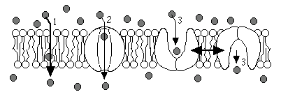

R

S

1. (i) Identify structures R and S in the diagram (2 marks)

____________________________________________________________

(ii) Identify and describe the processes taking place at points 1 and 3 in the diagram. (6 marks)

_________________________________________________________________________________________________________________________________________________________________________________________________________________________________________________________________________________________________________________

_____________________________________________________________

_____________________________________________________________

A student carried out some research to determine the concentration of chemicals in intracellular fluid as compared to extracellular fluid. The results are recorded in the table below.

|  |  |  |
| --- | --- | --- |
|  | EXTRACELLULAR  (mg) | INTRACELLULAR (mg) |
| Sodium | 137 | 10 |
| Potassium | 5 | 141 |
| Magnesium | 3 | 52 |
| Chloride | 103 | 4 |
| Phosphate | 4 | 75 |
| Glucose | 20 | 90 |

1. Identify the chemicals that would passively move into a cell according to this data.

(1 mark)

_____________________________________________________________

_____________________________________________________________

**Question 32 (11 marks)**

The table below gives information about three types of cartilage found in the body.

1. Complete the table by filling in the information on the function of each type of cartilage and where it can be found in the body. (3 marks)

|  |  |  |
| --- | --- | --- |
| **Type of cartilage** | **Function** | **Location in Human Body** |
| **Hyaline** |  |  |
| **Elastic** |  |  |
| **Fibrocartilage** |  |  |

1. Explain why damaged cartilage takes longer to heal that damaged bone.

(2 marks)

_______________________________________________________________________________________________________________________________________________________________________________________

1. As a person ages, they can begin to suffer from a condition which affects the cartilage, particularly cartilage with a weight bearing function.

Name this condition and outline the causes, symptoms and available treatment for a person suffering from this condition. (6 marks)

______________________________________________________________________________________________________________________________________________________________________________________________________________________________________________________________________________________________________________________________________________________________________________

__________________________________________________________________________________________________________________________

**Question 33 (7 marks)**

Complete cellular respiration is an enzyme controlled chemical reaction that provides cells with energy.

The diagram below shows the mitochondrion of a skin cell and of a muscle cell.

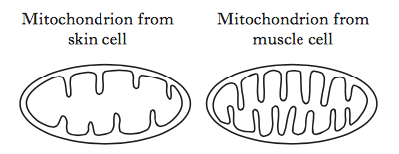

1. Explain the benefit of the mitochondrion of the muscle cell having a folded inner membrane. (2 marks)

_____________________________________________________________

_____________________________________________________________

The following diagram shows the steps involved in the partial breakdown of glucose in muscle cells.

Process A Process B

glucose 🡪 substance X 🡪 lactic acid

1. Name process A (1 mark)

__________________________________________

1. What name is given to substance X? (1 mark)

__________________________________________

1. Under what conditions might muscle cells be required to carry out anaerobic respiration? (1 mark)

_____________________________________________________________

_____________________________________________________________

1. Describe two effects of lactic acid on muscle cells. (2 marks)

_____________________________________________________________

_____________________________________________________________

**Question 34 (7 marks)**

Invertase is a human enzyme that breaks down sucrose into two products- glucose and fructose. It works best in neutral conditions.

The diagram below shows four test tubes.

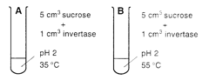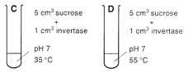

1. (i) In which of the test tubes above would you expect glucose to be detected first? (1 mark)

____________________________

(ii) Explain why you chose this test tube. (2 marks)

_____________________________________________________________

_____________________________________________________________

(iii) Explain why the enzyme amylase would not have been effective in carrying out this reaction. (2 marks)

_____________________________________________________________

_____________________________________________________________

(iv) List two variables that would be controlled during this experiment. (2 marks)

1. ______________________________________________
2. ______________________________________________

**Question 35**  **(12 marks)**

As exercise intensity increases, blood flow to the heart also increases.

An exercise program was designed to investigate the changes in the number of capillaries supplying blood to the heart muscle during exercise.

The data collected was recorded in the table below.

|  |  |  |  |  |  |  |
| --- | --- | --- | --- | --- | --- | --- |
| Number of capillaries per mm2 of heart muscle | 2000 | 2100 | 2250 | 2500 | 3000 | 3200 |
| Total distance run (km) | 0 | 50 | 100 | 150 | 200 | 250 |

1. Plot these results on the graph paper provided. (Additional graph paper can be found at the end of this question/ answer booklet.) (5 marks)



1. Write an appropriate hypothesis for this experiment (1 mark)

______________________________________________________________________________________________________________________

1. (i) Name the artery that supplies the heart muscle with its blood supply.

_________________________________________________ (1 mark)

(ii) Explain what would happen to the heart if this artery becomes blocked.

(2 marks)

_________________________________________________________________________________________________________________________________________________________________________________

1. Valves are found in the heart and also in veins but they are not found in arteries. State the function of valves and explain why they are necessary in veins but not in arteries. (3 marks)

______________________________________________________________________________________________________________________

______________________________________________________________________________________________________________________

**Question 36 (8 marks)**

The diagram below shows part of the respiratory system.

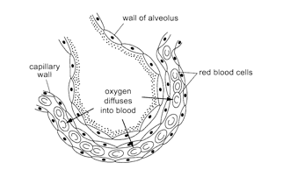

1. Describe three (3) adaptations of the gaseous exchange surface in humans which enhance the diffusion of respiratory gases. (4 marks)

_______________________________________________________________________________________________________________________________________________________________________________________________________________________________________________________________________________________________________

1. Jane is 74 years old and has been a smoker for most of her life. She now suffers from emphysema.

Explain how this may affect Jane in terms of her ability to exchange gases. (3 marks)

_______________________________________________________________________________________________________________________________________________________________________________________________________________________________________________________________________________________________________

1. Name another lung disease that could be caused by poor lifestyle choices. (1 mark)

___________________________________________________________

**Question 37 (11 marks)**

The diagram below shows the structure of a villus.

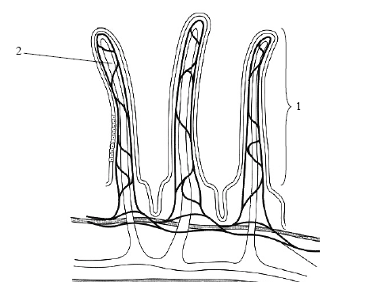

1. Name vessel 2 (1 mark)

_____________________________________________________________

1. Describe the role of vessel 2 in the transport of nutrients. (2 mark)

_____________________________________________________________

1. Outline the role of the villi in the small intestine and explain why its structure is suited to its function. (4 marks)

_____________________________________________________________

_____________________________________________________________

_____________________________________________________________

_____________________________________________________________

_____________________________________________________________

1. Name the blood vessel which transports nutrient-rich blood away from the small intestine. (1 mark)

_____________________________________________________________

1. Some nutrients will be absorbed into the blood against the concentration gradient. Name this process. (1 mark)

_____________________________________________________________

1. During the process of digestion, large molecules are broken down into smaller, usable molecules by mechanical and chemical digestion.

Bile assists in the process of digestion.

1. Which large molecules does bile break down? (1 mark)

________________________________________________________

1. Does bile break down this molecule mechanically or chemically?

(1 mark)

________________________________________________________

**Question 38 (7 marks)**

The kidney is the body’s main organ of excretion. Every day our kidneys filter approximately 100-140 litres of blood and produce 1-2 litres of urine. Our urine consists mainly of excess water and waste.

The diagram below shows the part of the kidney involved in filtration.

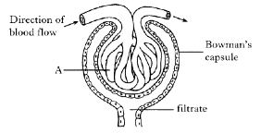

1. (i) Part A consists of a bundle of capillaries. Name part A. (1 mark)

_____________________________________________________________

(ii) What feature, shown in the diagram, results in high pressure within structure A? (1 mark)

_____________________________________________________________

(iii) In which part of the nephron does the filtrate flow immediately after leaving the Bowman’s capsule? (1 mark)

_____________________________________________________________

1. The table below shows the composition of filtrate and urine.

|  |  |  |
| --- | --- | --- |
| ***Substance*** | ***Mass in filtrate***  ***(g/day)*** | ***Mass in urine***  ***(g/day)*** |
| Sodium ions  Potassium ions  Glucose  Urea  water | 600  35  200  60  180 000 | 6  2  0  36  1500 |

1. Name the process that results in the differences between filtrate and urine, shown in the table. (1 mark)

___________________________________________________________

1. What percentage of urea returns to the blood as the filtrate flows through the nephron? (1 mark)

__________________________ %

1. Predict how the composition of urine would differ if the individual was an untreated diabetic. (2 marks)

___________________________________________________________

___________________________________________________________

**Question 39 (14 marks)**

The diagram below shows the muscles and bones involved in the movement of the forearm.

1. Referring to the diagram below, which letters identify the following:

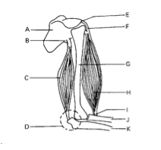

Agonist _____________ (1 mark)

Antagonist _____________ (1 mark)

Humerus _____________ (1 mark)

Scapula _____________ (1 mark)

1. Describe two differences between the microscopic structure of cancellous bone and compact bone. (4 marks)

_________________________________________________________________________________________________________________________________________________________________________________________________________________________________________________________________________________________________________________

1. The point at which two or more bones meet is referred to as a joint. Complete the table below by giving an example of where the type of joint is found in the body. (3 marks)

|  |  |
| --- | --- |
| Joint Type | Example of Joint |
| Saddle Joint |  |
| Cartilaginous joint |  |
| Pivot Joint |  |

The diagram below identifies the main structures in a general synovial joint.

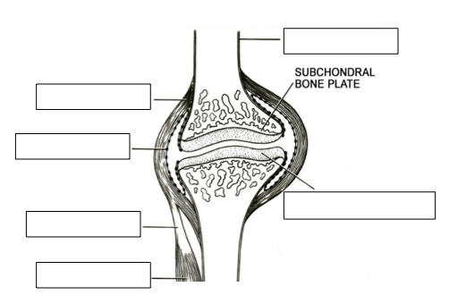

1. Label the above diagram. (3 marks)

**End of section 2**

**Section Three: Extended answer 20% (40 Marks)**

This section contains **two (2)** questions. You must answer **one (1)** question. Write your answer in the space provided.

Spare pages are included at the end of this booklet. They can be used for planning your response and/or as additional space if required to continue an answer.

* + Planning: If you use the spare pages for planning, indicate this clearly at the top of the page.
  + Continuing an answer: If you need to use the space to continue an answer, indicate in the original answer space where the answer is continued i.e. give the page number. Fill in the number of the question(s) that you are continuing to answer at the top of the page.

Responses could include clearly labelled diagrams with explanatory notes, lists of points with linking sentences, clearly labelled tables and graphs and annotated flow diagrams with introductory notes.

Suggested working time: 20 minutes.

**Question 40 (20 marks)**

1. Give an account of the circulation of blood under the following headings:
2. pulmonary circulation (5 marks)
3. systemic circulation (5 marks)
4. Blood transfusions save thousands of lives across Australia every year. Before receiving a blood transfusion, it is important to know what your blood group is. Using an example from the ABO blood group system, explain what determines a person’s blood group and why it is important to know what your blood groups is before receiving a transfusion. (6 marks)
5. The structure of veins and arteries are specific to their function. Outline two (2) differences between veins and arteries. (4 marks)

**Question 41 (20 marks)**

Our muscles and bones work together and thus allow us to move in a controlled manner. Muscle must contract and relax for this movement to take place. Scientists have developed the ‘sliding filament theory’ to explain the contraction of skeletal muscle.

1. Name and briefly describe the structures that hold muscles and bones in place. (4 marks)
2. A weight lifter carries out several types of movement at the knee and elbow joints in order to pick up a weight correctly and lift it above their head. Outline four (4) types of movement that can take place at a joint in order for this person to successfully lift the weight. (8 marks)
3. Scientists have developed the ‘sliding filament theory’ to explain the contraction of skeletal muscle. Outline the sliding filament theory. (8 marks)

Question _________________________

___________________________________________________________________

_____________________________________________________________________________________________________________________________________________________________________________________________________________________________________________________________________________________________________________________________________________________________________________________________________________________________________________________________________________________

_____________________________________________________________________________________________________________________________________________________________________________________________________________________________________________________________________________________________________________________________________________________________________________________________________________________________________________________________________________________

_____________________________________________________________________________________________________________________________________________________________________________________________________________________________________________________________________________________________________________________________________________________________________________________________________________________________________________________________________________________

_________________________________________________________________________________________________________________________________________________________________________________________________________

Question __________________

_____________________________________________________________________________________________________________________________________________________________________________________________________________________________________________________________________________________________________________________________________________________________________________________________________________________________________________________________________________________

_____________________________________________________________________________________________________________________________________________________________________________________________________________________________________________________________________________________________________________________________________________________________________________________________________________________________________________________________________________________

_____________________________________________________________________________________________________________________________________________________________________________________________________________________________________________________________________________________________________________________________________________________________________________________________________________________________________________________________________________________

_________________________________________________________________________________________________________________________________________________________________________________________________________

Question ________________

_____________________________________________________________________________________________________________________________________________________________________________________________________________________________________________________________________________________________________________________________________________________________________________________________________________________________________________________________________________________

_____________________________________________________________________________________________________________________________________________________________________________________________________________________________________________________________________________________________________________________________________________________________________________________________________________________________________________________________________________________

_____________________________________________________________________________________________________________________________________________________________________________________________________________________________________________________________________________________________________________________________________________________________________________________________________________________________________________________________________________________

_________________________________________________________________________________________________________________________________________________________________________________________________________

Question _________________

_____________________________________________________________________________________________________________________________________________________________________________________________________________________________________________________________________________________________________________________________________________________________________________________________________________________________________________________________________________________

_____________________________________________________________________________________________________________________________________________________________________________________________________________________________________________________________________________________________________________________________________________________________________________________________________________________________________________________________________________________

_____________________________________________________________________________________________________________________________________________________________________________________________________________________________________________________________________________________________________________________________________________________________________________________________________________________________________________________________________________________

_________________________________________________________________________________________________________________________________________________________________________________________________________

Question __________________

_____________________________________________________________________________________________________________________________________________________________________________________________________________________________________________________________________________________________________________________________________________________________________________________________________________________________________________________________________________________

_____________________________________________________________________________________________________________________________________________________________________________________________________________________________________________________________________________________________________________________________________________________________________________________________________________________________________________________________________________________

_____________________________________________________________________________________________________________________________________________________________________________________________________________________________________________________________________________________________________________________________________________________________________________________________________________________________________________________________________________________

_________________________________________________________________________________________________________________________________________________________________________________________________________

Question __________________

_____________________________________________________________________________________________________________________________________________________________________________________________________________________________________________________________________________________________________________________________________________________________________________________________________________________________________________________________________________________

_____________________________________________________________________________________________________________________________________________________________________________________________________________________________________________________________________________________________________________________________________________________________________________________________________________________________________________________________________________________

_____________________________________________________________________________________________________________________________________________________________________________________________________________________________________________________________________________________________________________________________________________________________________________________________________________________________________________________________________________________

_________________________________________________________________________________________________________________________________________________________________________________________________________

Question _________________

_____________________________________________________________________________________________________________________________________________________________________________________________________________________________________________________________________________________________________________________________________________________________________________________________________________________________________________________________________________________

_____________________________________________________________________________________________________________________________________________________________________________________________________________________________________________________________________________________________________________________________________________________________________________________________________________________________________________________________________________________

_____________________________________________________________________________________________________________________________________________________________________________________________________________________________________________________________________________________________________________________________________________________________________________________________________________________________________________________________________________________

_________________________________________________________________________________________________________________________________________________________________________________________________________

Question __________________

_____________________________________________________________________________________________________________________________________________________________________________________________________________________________________________________________________________________________________________________________________________________________________________________________________________________________________________________________________________________

_____________________________________________________________________________________________________________________________________________________________________________________________________________________________________________________________________________________________________________________________________________________________________________________________________________________________________________________________________________________

_____________________________________________________________________________________________________________________________________________________________________________________________________________________________________________________________________________________________________________________________________________________________________________________________________________________________________________________________________________________

__________________________________________________________________



Image References

Question 1- accessed 14th January 2016

Phagocytosis <http://www.mrothery.co.uk/cells/cellnotes.htm>

Question 2- accessed 14th January 2016

Model cell diagram (osmosis) <http://www2.sluh.org/bioweb/apbio/labs/apl01.htm>

Question 17- accessed 14th January 2016

Respiratory system <http://www2.sluh.org/bioweb/apbio/studysheets/ss_gas_exchange_in_animals.htm>

Question 18- accessed 14th January 2016

Microscopic structure of bone <http://etc.usf.edu/clipart/50700/50764/50764_micro.htm>

Question 19- accessed 16th January 2016

Joint <http://www.gamradtortho.com/conditionsShoulderArthritis.php>

Question 23- accessed 16th January 2016

Kidney cross section- <http://www.slideshare.net/qusaikhashman/0610-w07-qp3-47239536>

Question 26 & 27- accessed 16th January 2016

Digestive system <http://antomybodydiagram.info/page/159/>

Question 29- accessed January 16th 2016

Heart- <http://www.clipartbest.com/unlabelled-diagram-of-the-heart>

Question 30- accessed 16th January 2016

Sarcomere <http://peir.path.uab.edu/library/picture.php?/31494>

Question 31b) accessed 20th January 2016

Membrane <http://home.earthlink.net/~dayvdanls/cell_membranes.htm>

Question 34a) accessed 23rd January 2016

Enzymes- <http://www.slideshare.net/bfurlong/biology-lab-book>

Question 37a) accessed 23rd January 2016

Gas exchange- <http://www.abahe.co.uk/encyclopedia-images/A-Z-Health-and-Social-Care-Handbook/Gaseous%20exchange.png>

Question 38a) accessed 23rd January 2016

Villus- [http://www.bio12.com/ch12/](http://www.bio12.com/ch12/pastexams.htm)

Question 40a) accessed 27th January 2016

Muscles and bones- <https://www.pinterest.com/pin/98868154295664007/>

Question 40d) accessed 23rd January 2016

Synovial joint- <https://www.pinterest.com/j9mm2/anatomy/>